- Make heading green color like below in – ‘You may be here’ section and ‘tools we may use’ section:
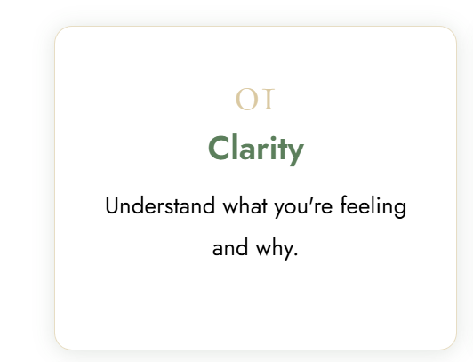
- Reduce the font size by 1 point of the headings on the boxes.
- Extend this box 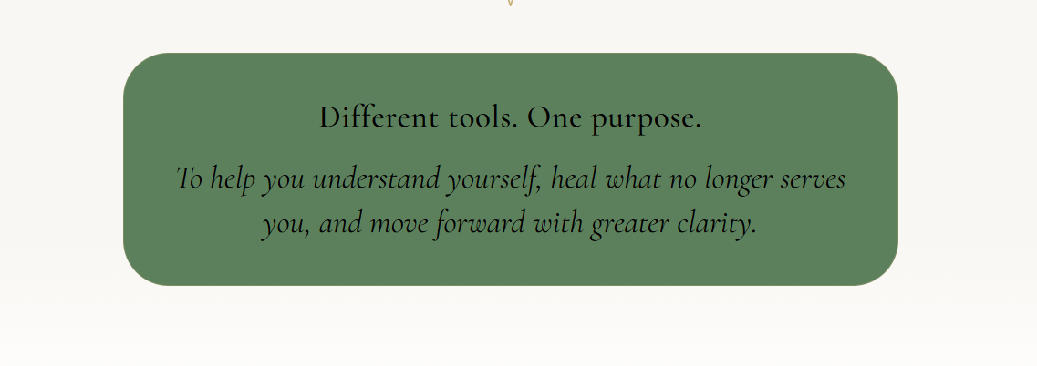
- Design the booking section like this one – left to right reading with CTA below. Also change the BKG color of this section.
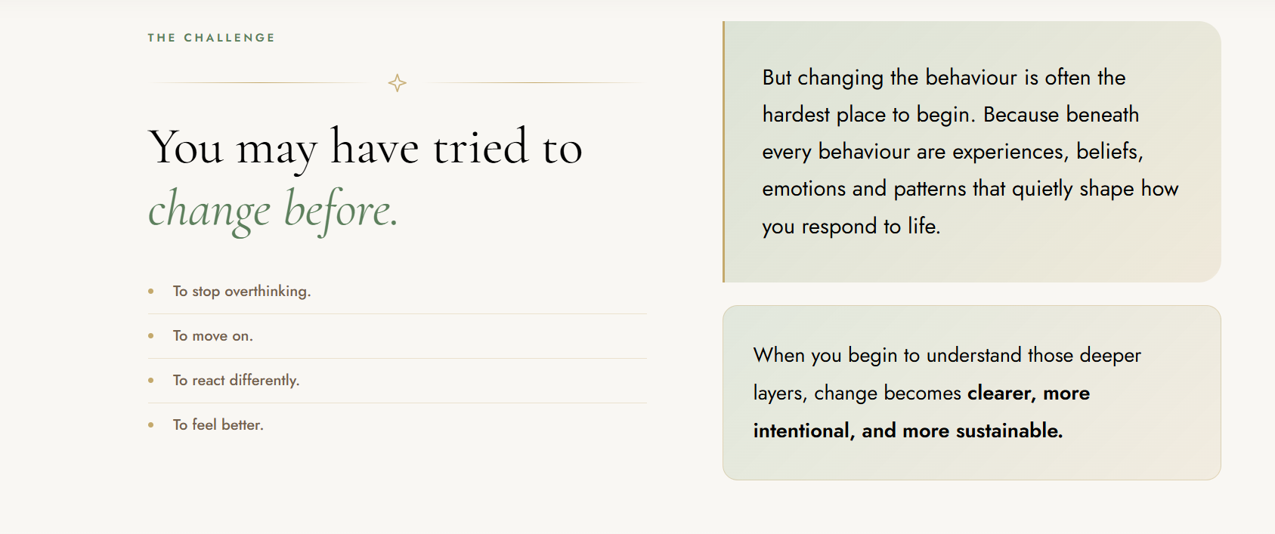

- Approach in the menu bar is wrongly linked.
- Banner is merging with header
- Wrong logo in about page header and footer
- Wrong logo in insights page header
- Remove animation and put the logo in image format
- Remove the background from banner section
- CTA in banner section to be of same color as in the intro – green. All three CTA’s on home page to be same color green.
- Correct the logo – it is distorted.
- Let’s make this color little lighter: 
- Footer Line below the logo –
A safe space to support a deeper shift in the way you think, feel, respond, relate and live.
- Change ‘Request a call’ to ‘Begin your journey’. And the link on menu isn’t working.
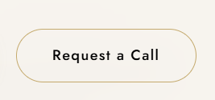
- Mobile version + alignment
- All booking CTA hyperlinked to connect page.
- CTA in about page –Only one CTA – Book your free consultation.

Requirements from me:
- Phone no: 9817835553
- Email: manila@enersoulhealing.com
- Location: Karnal, Haryana
- Fb Link:
https://www.facebook.com/share/1C1QeuBqiy/?mibextid=wwXIfr
- Insta Link: will update in the coming month. Page is WIP.

Changes – 09/10

- Change the text color to dark.. if possible use the logo if different orientation (icon on top and name below)
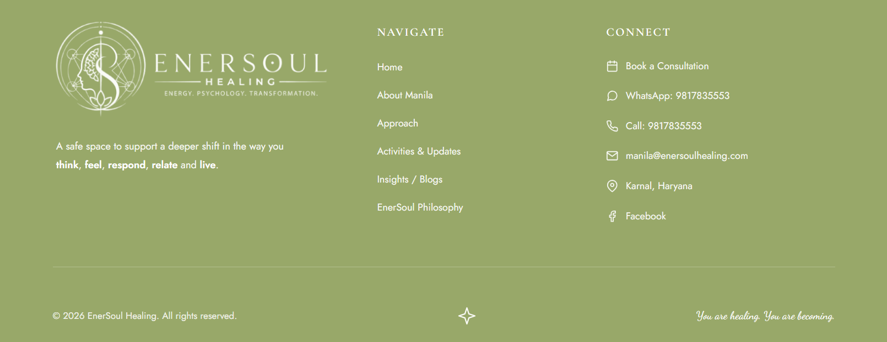

- Change it to – Begin your journey (Not ‘our’)


- On home page – change the copy of the CTA to same as about page - 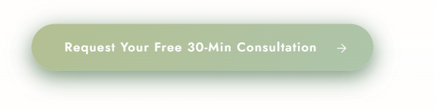
- The whatsapp message – Hi Manila, I came across EnerSoul Healing and would like to request my first complimentary 30-minute consultation. I’d love to have a conversation about what I’m currently experiencing and understand how we can work together.
- We can reduce the height of this space a bit I mean the menu

- Change all holistic words to ‘energy’ (there are three in the about page and one on the home page)

- CTA on Footer – Change the copy to Begin Your Journey


- Change the copy from Approach to EnerSoul Approach


